Dr. Yasmeen Jasim post mortem Forth stage

Black leg disease

Blackleg is an infectious, non-contagious disease caused by Clostridium chauvoei. Infection occurs when animals ingest bacterial spores . The bacterial spores penetrate the intestine and are disseminated via the bloodstream to the skeletal muscle, where the spores remain dormant. Following an event that causes low oxygen conditions (i.e. bruising or damage to the muscle) in infected tissue, the spores germinate, multiply and produce toxin that results in muscle necrosis and hemorrhage. The animals affected by blackleg are usually well fed animals between 6 months and 2 years of age. The cause of death in affected animals is usually acute toxemia. The course of the disease is often between 12-48hours clinical signs are often absent; however, animals may exhibit signs of lameness, tachycardia, fever, anorexia, rumen stasis and lethargy. Blackleg is primarily a disease of animals with the majority of the cases occurring during the summer months.

Blackleg in sheep is often associated with a wounds such as shearing, tail docking, castration, injury to ewes during birthing, or infection of the navel in lambs soon after birth. The bacteria enters the bloodstream and lodges in the muscle where it multiplies, causing inflammation of the muscle tissue.

The gross lesions

included variably sized areas of skeletal muscle that was dark red and contained gas bubbles (necrotizing myositis). Due to the intramuscular gas bubbles, affected sections of skeletal muscle would often float in formalin. Most of the affected animals had a fibrinous pericarditis and necrotizing myocarditis. The skeletal muscle and myocardial lesions typically had the faint to pervasive odor of rancid butter. The diagnosis of blackleg was based on the characteristic gross lesions and a positive fluorescent antibody test results on affected tissues.

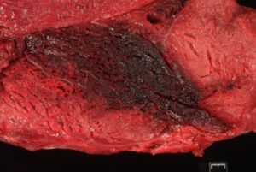Skeletal muscle. Characteristic necrotizing myositis and gas bubble formation associated with blackleg.

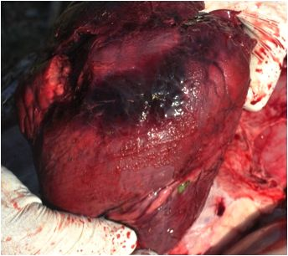 Right ventricle showing dark red patch of myonecrosis and fibrin tags.

Lamb dysentery

is fatal enterotoxaemia of young lambs caused by the beta and epsilon toxins of Clostridium perfringens type B. C. perfringens is a large, gram positive, anaerobic bacillus that is ubiquitous in the environment and the gastrointestinal tract of most mammals.

Enterotoxaemia due to Clostridium perfringens type B causes severe enteritis and dysentery with a high mortality in young lambs (lamb dysentery), but also affects calves, pigs, and foals. The β toxin it produces is highly necrotising and is responsible for severe intestinal damage. toxin also plays a part in pathogenesis. Outbreaks of lamb dysentery typically occur during cold, wet lambing periods when lambing ewes are confined to small areas of shelter which rapidly become unhygienic. Most cases are seen in stronger, single lambs because these animals consume the largest quantities of milk, which functions as a growth medium for C. perfringens.

Clinical Signs
Lamb dysentery often presents as sudden death of lambs less than 2-3 weeks old. When clinical signs are seen, these include cessation of suckling, depression and recumbency. Animals suffer acute abdominal pain, and semi-fluid blood-stained faeces may be passed .

post-mortem examination, segments of the intestines appear dark red-purple and distended, and show mucosal ulceration. The peritoneal fluid is blood-stained and liver may be pale and friable. The kidneys are often enlarged.
Histologically, numerous gram-positive rods are present in intestinal smears and scrapings.

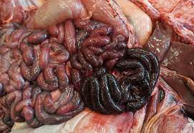

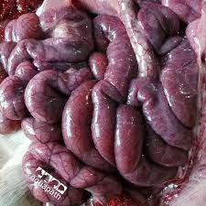

segments of the intestines appear dark red-purple and distended

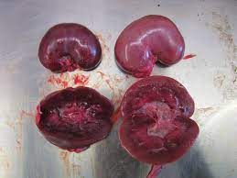 The kidneys are often enlarged.

Thank you

